Mit freundlichen Grüßen / Best regards,

Name Lastname
______________________________________

WeWire Harness (Mianyang) Co., Ltd.

Name Lastname
Position

Building 8, #18 Chuangxin Road,
Longshen Industrial Park
621000 Mianyang, Sichuan Province, China
T +86 181 4255 XXX
M +86 XXX XXX XXX
firstname.name@wewire-harness.com
www.wewire-harness.cn
_____________________________________

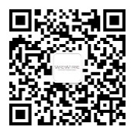
Follow us on WeChat!

